RirekiSHOW!!

A responsive portfolio website to make an impact during job-hunting as “First impression is the last impression”.

Soujanya Dash  
Undergraduate (APM), 2021

Ritsumeikan Asia Pacific University-Japan

*Abstract*—In this paper I propose a third-party website for job hunting and recruiting for both client and server side, called RirekiSHOW project. It is not just restricted to Japan but can be used by any foreign company or employee with the websites with user friendly systems such as AI powered suggestions, filters, newsletters etc. Even though there may be existing websites, the unique selling features are translation crowdsourcing (of resumes) and E-handshake which are beneficial during the pandemic. Given responsive website, the data will be collected through crawling along with data provided by users and will be stored in a database. For AI and data disclosure, there will be policies for the security purposes along with DDoS cloudflare protection.

Keywords-component: resume website, jobs in Japan, third-party intermediary, Online job hunting & recruiting, interoperability.

# Introduction

## Background

Foreign students usually face problem when communicating in a non-native language which may reduce the chances of getting a decent job. Similarly, companies want to find the best individual (person-organization fit). During the pandemic, employers had to resort to the online platform for recruiting and screening for which the need of an online arena for job hunting was a must. This situation gave rise to “RirekiSHOW!!” project, derived from the Japanese word for resume that is representable or “shown” to potential employers. which has features like filters, resume strength checking, E-handshake system, automatic translation etc. in addition to common website features like dashboard, AI powered suggestions, navigation and drop-down, privacy(disclaimer) etc.

## Purpose of this work

In this work the author proposes a third-party intermediary between companies and potential employee who can connect irrespective of language barrier and distance.

# e-handshake: A solution during pandemic

There are two main ways by which our website is different from existing ones like LinkedIn and Recruit Japan. First, crowdsourcing of translation service (Fig. 2) if the google translate didn’t work well. There will be privacy policy to prevent misuse of data and secure confidentiality of the person. The information which will not be disclosed is of username, user ID, address, and mobile number etc. Second, E-handshakes (Fig. 3) which is a great opportunity for making deals during the pandemic era. To ensure the confidentiality between the client and the server site and the integrity of the communicated data, **digital handshakes** will be usedas a protocol in web security. There is another form of handshake which is SSL/TSL which is a negotiation between two parties in the network such as the browser and the web server which helps in establishing the details between the connection. IoT is implemented in this process as it can promote interoperability between IoT devices.

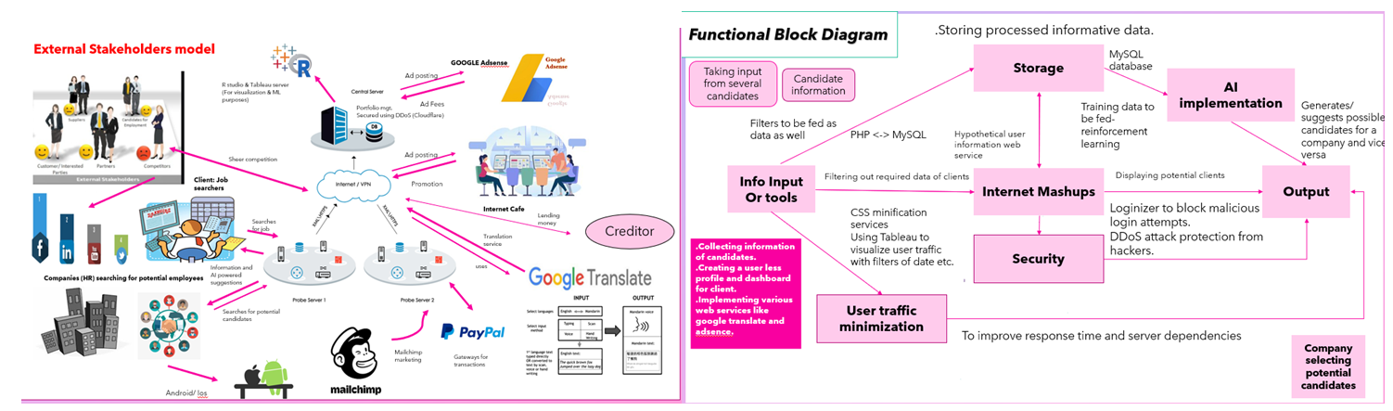

Figure 1 Network Architecture and stakeholders

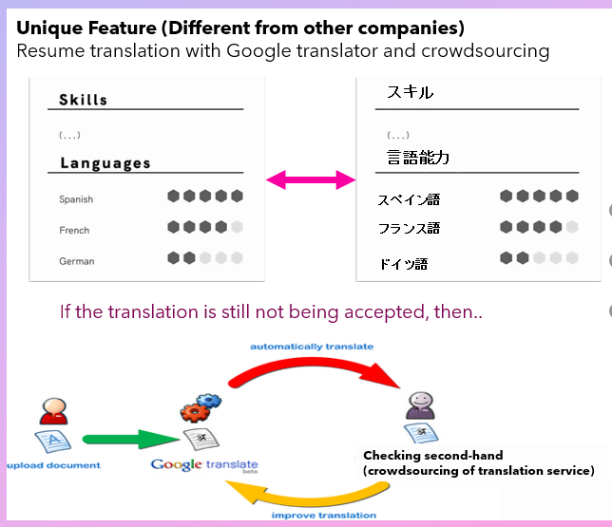

Figure 2 Unique feature 1: Crowdsourcing of translation service on request

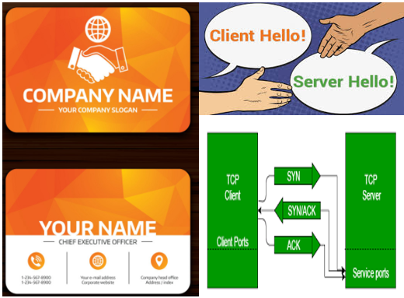

Figure 3 E-handshake system

##### References

1. Schmitt, C. & Stiller, B.(2016), "TinyTO:two-way authentication for constrained devices in the Internet of Things", CSG, Department of Informatics IFI, University of Zurich, pp. 239-258.
2. Gupta, R. & Anastasiou, D. (2011). “Comparison of crowdsourcing translation with Machine Translation”. Journal of Information Science. Vol. 37, Issue 6, pp.637-659.